Reflective foil on _______. Stops h_______ entering as radiant heat from the s______. | Heading | Double glazing. Stops heat loss and gain by conduction through the w_________
Light coloured roof.  This reflects _________ and helps keep the house _________ in summer. So less energy needs to be spent on a___-_________ | 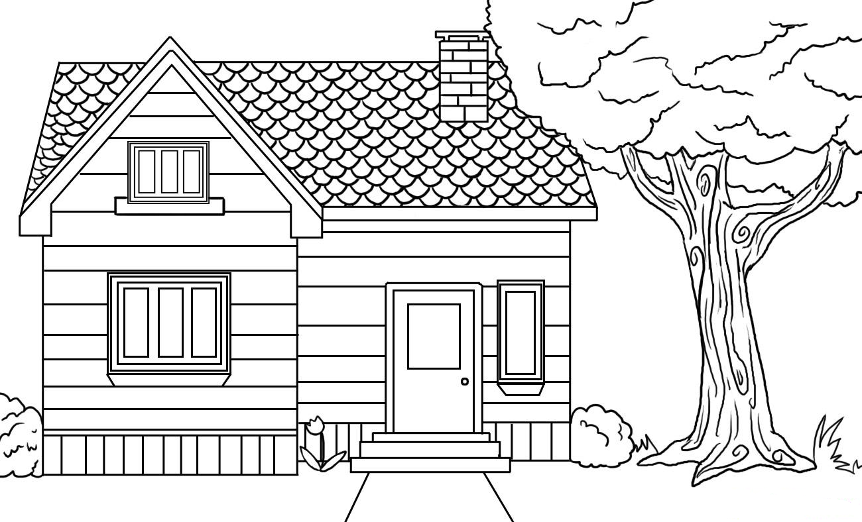 | Shade tree. This blocks some of the light hitting the house. So the house stays _________ in summer.  Stops h______ by radiation.
Insulation in roof c___________.  Stops heat loss and g____ by c________.  So house is w________ in winter and c______ in summer |  | Solar heating. Uses r_______ energy from the s____ to heat water. So m_______ can be saved as less e______ needs to be used to heat w________
Use f___________ or __.__.__ lights as they are more efficient than traditional incandescent lights. |  | Light coloured house walls. This reflects _________ and helps keep the house _________ in summer. So less energy needs to be spent on a___-_________.
 | Words to use. Dish washer, Sun, summer, cooler, air-conditioning, light, space, fluorescent, L.E.D. gain, conduction, heating, windows, warmer, cooler, lights, showers, cavity, conduction, warmer, cooler, radiant, money, energy, water. Heading = Energy Efficiency In the Home. | Behaviour. Turn off ________ when not in use. Have shorter _________. Fill ______________ __________ before use.

I | F | M | H | N | D | Q | R | P | J | J | S | C | S | R
Y | N | X | O | F | U | Q | E | N | T | A | O | B | H | E
H | G | S | C | N | N | S | F | P | V | N | S | G | O | M
J | D | R | U | N | E | V | L | E | D | G | H | N | W | M
P | U | X | E | L | O | Y | E | U | N | T | A | I | E | U
K | V | Q | J | N | A | I | C | I | K | S | D | T | R | S
R | L | Q | O | T | E | T | T | W | R | V | E | H | S | L
P | R | Q | Z | S | I | A | I | A | A | R | X | G | P | N
F | Q | W | S | O | E | C | V | O | I | R | T | I | G | R
X | I | U | N | H | N | F | E | C | N | D | M | L | O | A
Y | C | N | E | I | C | I | F | F | E | N | A | I | E | R
C | O | O | L | I | N | G | W | I | N | T | E | R | N | Y
G | N | I | Z | A | L | G | E | E | R | T | F | X | I | G
T | W | D | G | G | T | S | J | V | N | A | P | S | J | E
D | F | L | U | O | R | E | S | C | E | N | T | N | G | A

CONDUCTION | COOLING | EFFICIENCY
ENERGY | FLUORESCENT | GLAZING
HEATING | INSULATION | LIGHTING
MONEY | RADIATION | REFLECTIVE
SAVE | SHADE | SHOWERS
SUMMER | SUN | TREE
WARMING | WINTER

